|  |
| --- |
|  |

**LAB 1: Getting started with MongoDB**

|  |  |
| --- | --- |
| **Track** | Data & AI |
| **Role** | Software Development - Backend |
| **Level** | Level 2 |
| **Course** | NoSQL Databases |
| **Scope** | * Install and configure MongoDB on Windows OS. * Create and manage collections with sample telecom data. * Perform data queries and manipulations using MongoDB Compass (UI). |
| **Prerequisite** | * Basic knowledge of databases and collections. * Windows OS installed on your system. * Administrative rights on your machine for installing software. |

**Objective**

To equip participants with foundational skills in MongoDB by installing and configuring the environment on Windows OS, creating and managing collections with telecom data, and performing data queries and manipulations using MongoDB Compass (UI).

**Tasks**

**Dataset (also available in resources): telecom_dataset.json**

**Installing MongoDB:**

* Download the MongoDB installer from the official website for Windows.
* Complete the installation and ensure MongoDB Compass is installed and launched.

1. **Create a New Database and Collection:**

* Set up a new database in MongoDB Compass and name it accordingly.
* Create a collection for storing customer data within the database.
* Manually insert sample customer data into the collection.

1. **Insert Data Using Queries:**

* Create an additional collection for storing plans.
* Use MongoDB query commands to insert multiple plan documents into the collection.
* Run queries to view and verify the inserted data in the collection.

**Outcomes**

* Set up and configure MongoDB on Windows OS.
* Create and manage databases, collections, and insert data using MongoDB Compass.
* Perform queries and data manipulation within a MongoDB environment using both UI and commands.

**Solution**

##### Installing MongoDB:

* 1. Download MongoDB Installer:
  + Visit the [official MongoDB website](https://www.mongodb.com/try/download/community).
  + Choose **Windows** as the operating system
  + Select the preferred download method (e.g., MSI).
  + Click **Download**.

* 1. Install MongoDB
  + Open the downloaded .msi installer.
  + Click on Next and I accept terms.
  + Choose **Complete** setup when prompted.

* + Click on Run Service as Network Service user.
  + And Click on Next until you see below image.

* + Once you see this prompt click on Install button(also click on yes when it ask you to make change In your system).
  + Once all done Click on Finish.
  + There will be MongoDB compass open in background.
  + Click on **Start** button.

##### Create a New Database and Collection

* 1. **Create Database**:
  + To connect Database click on Add new connection.

* + Give name to you connection
  + And connect it by clicking on connect button.

* + Let’s create database and collection.
  + Click on create database.

* + For database name it TelecomDB
  + For the first collection, name it Customers.
  + And Click on **Create Database**

* 1. **Manually Insert Sample Data**
  + In MongoDB Compass, navigate to the Customers collection within the TelecomDB database.
  + Click on the Insert Document button.
  + A blank JSON document will appear where you can manually input data.

* + Replace blank JSON document with the Customer 1 data below.  
      
    Customer 1:

{

  "CustomerID": 101,

  "Name": "John Doe",

  "PhoneNumber": "9876543210",

  "SubscriptionType": "Prepaid",

  "ActiveStatus": true,

  "Plan": {

    "PlanName": "Basic",

    "Price": 199,

    "DataLimit": "2GB",

    "Validity": "28 Days"

  }

}

* + After adding data of Customer 1, Click on **Insert** button.

* + Repeat the process to add below customer data.

Customer 2:

{

  "CustomerID": 102,

  "Name": "Jane Smith",

  "PhoneNumber": "9123456789",

  "SubscriptionType": "Postpaid",

  "ActiveStatus": true,

  "Plan": {

    "PlanName": "Unlimited",

    "Price": 999,

    "DataLimit": "Unlimited",

    "Validity": "Monthly"

  }

}

Customer 3:

{

  "CustomerID": 103,

  "Name": "Michael Johnson",

  "PhoneNumber": "9988776655",

  "SubscriptionType": "Prepaid",

  "ActiveStatus": false,

  "Plan": {

    "PlanName": "Family",

    "Price": 499,

    "DataLimit": "5GB",

    "Validity": "56 Days"

  }

}

Customer 4:

{

  "CustomerID": 104,

  "Name": "Emily Davis",

  "PhoneNumber": "9765432101",

  "SubscriptionType": "Postpaid",

  "ActiveStatus": true,

  "Plan": {

    "PlanName": "Premium",

    "Price": 1299,

    "DataLimit": "Unlimited",

    "Validity": "Monthly"

  }

}

* + Once all data are inserted let’s try some query.

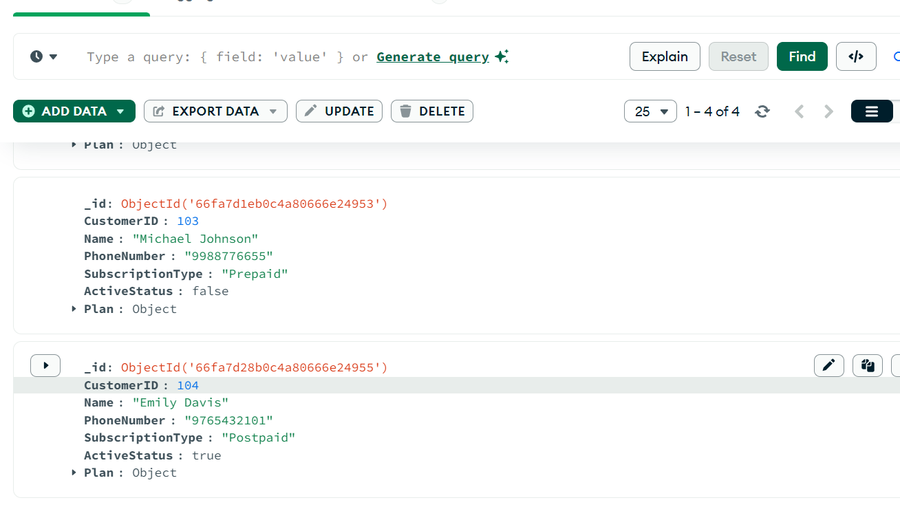

* + Once all data are inserted let’s Explore the Inserted Data with help of query.
  + Use MongoDB Compass's **Filter** bar to run basic queries.
  + To **Find all active customers**:

{ "ActiveStatus": true }

* + Output of the query will be quite similar to output image below.

* + To **Find customers with a prepaid subscription**:

{ "SubscriptionType": "Prepaid" }

* + Output of the query will be quite similar to output image below.

##### Insert data with help of query

* 1. **Before adding data let’s Create Another Collection:**
  + In MongoDB Compass, click on **Create Collection** within the **TelecomDB** database.
  + Name the new collection **Plans**.

* 1. **Use Query to Insert Data in Plan:**
  + **Click on the Command tab** or **Query Bar** within the Plans collection.
  + Paste the query from below and **click Run**.

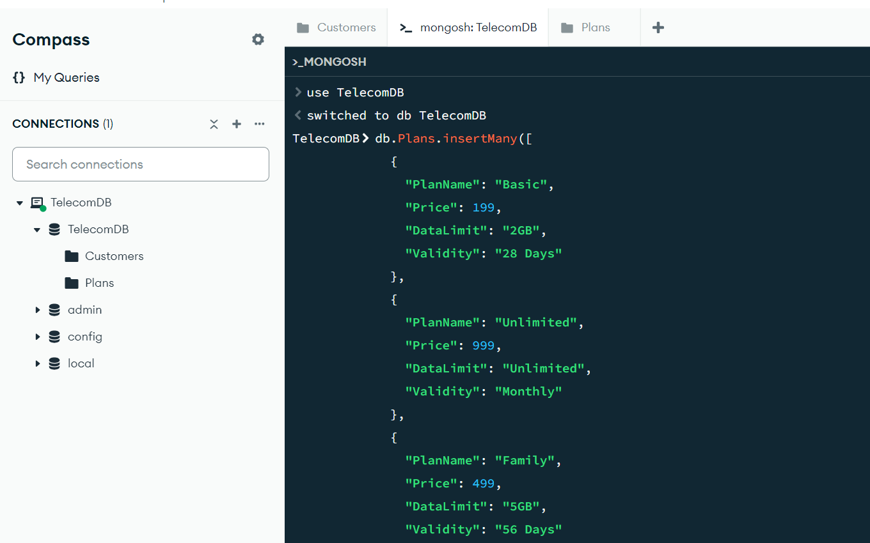

* + Query is here below use it to insert data:

db.Plans.insertMany([

  {

    "PlanName": "Basic",

    "Price": 199,

    "DataLimit": "2GB",

    "Validity": "28 Days"

  },

  {

    "PlanName": "Unlimited",

    "Price": 999,

    "DataLimit": "Unlimited",

    "Validity": "Monthly"

  },

  {

    "PlanName": "Family",

    "Price": 499,

    "DataLimit": "5GB",

    "Validity": "56 Days"

  },

  {

    "PlanName": "Premium",

    "Price": 1299,

    "DataLimit": "Unlimited",

    "Validity": "Monthly"

  }

]);

* + Reopen or refresh Plan’s to see updated data.

